Directions: Copy and paste into an email, adjusting the text for your audience as needed.

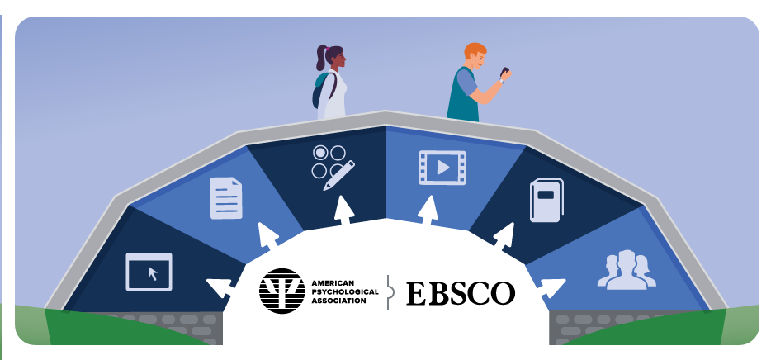

Dear _____________,

I’d like to take a moment to tell you about the online resources from the American Psychological Association (APA) available through our library. The following databases are available on EBSCOhost/EBSCO Discovery Service and can be accessed on desktops, laptops, tablets and mobile devices:

- APA PsycInfo® ─ Unparalleled Index of Peer-Reviewed Literature
  - More than 4.8 million bibliographic records
  - Indexing of more than 2,200 journals, 99% of which are peer-reviewed
- APA PsycTherapy® ─ Covers Authentic Therapy Sessions
  - More than 500 videos showing various treatment approaches
  - Proven methods showcasing common obstacles faced during therapy sessions
- APA PsycBooks® ─ The APA’s Electronic Library of Full-Text Books
  - More than 67,000 book chapters and 4,500 peer-reviewed books
  - The newest APA books as they are published
  - The entire reference book series, “APA Handbooks in Psychology^{®I}
- APA PsycArticles® ─ Full-Text, Peer-Reviewed APA Journal Articles
  - More than 217,000 full-text articles from more than 100 journals, each employing a meticulous peer-review process
  - Articles from APA journals, which have a significantly higher share of citations relative to the number articles published
  - Coverage for most journals from Volume 1, Issue 1
- APA PsycTests® ─ Thousands of Research Instruments and Their Psychometric Properties
  - More than 61,000 records
  - Includes descriptive fields, including Methodology, Test Language and Factors/Subscales, as well as a list of Source Citations for records with corresponding APA PsycInfo and APA PsycExtra records
- APA Extra® ─ Unique Full Text Materials
  - Conference presentations, newsletters, reports, fact sheets, magazines, monographs and more
  - More than 300,000 records and growing
  - Full text for more than 70% of records
For access, go to http://search.ebscohost.com.

Please feel free to contact me directly with any questions, or if you have suggestions about other ways we can help support you via the library’s online resources.

Regards,

[Insert your name & contact information and delete this note]

