Instructions for Use: Simply select the entire table below, copy it and paste it into the body of your email. Then select the entire table again and center the table in the body of your email.

Subject Line: Important Information About the New Version of DynaMed Coming August 21

DynaMed is undergoing some exciting
changes on August 21, 2019.

And we want to make sure you are ready for the new experience.

The next generation of DynaMed combines the highest quality evidence-based information with a user-friendly, personalized experience that delivers
accurate answers fast.

Watch the video below for a sneak peek of what’s to come from DynaMed.

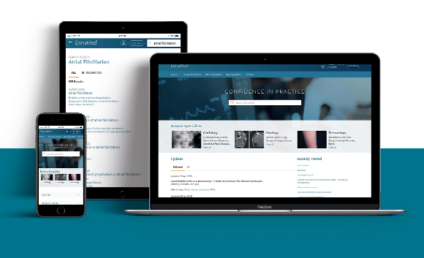
What do I need to know?
Your evidence-based, point-of-care tool will simply be called DynaMed.
You’ll be able to personalize your DynaMed experience with improved topic and evidence alerts and a seamless mobile app integration.
DynaMed now provides Maintenance of Certification credits in addition to AMA, AAFP, and AANP CME.
What do I need to do?
No changes need to be made to your existing personal user account. If you have CME credits to claim, please do so before August 14, 2019.
Watch a quick preview video of the new product or register for a live learning session online.

