Directions: Copy and paste into an email, adjusting the text for your audience as needed.

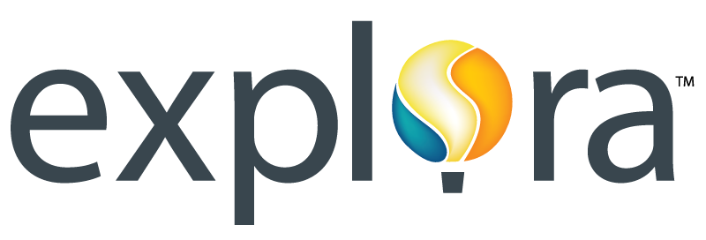

Dear Library Patron,

I’d like to take a moment to tell you about the online resources offered by EBSCO, now available in our library through an engaging interface called Explora. Designed with public library patrons in mind, Explora provides easy-to-use features and reliable content from the world’s leading magazines and reference books. Available on library computers and from mobile devices, Explora offers the following:

- High-quality content licensed from reputable publishers recognized by library professionals
- Simple search that quickly delivers relevant results, including magazine and journal articles, primary source documents, newspaper articles and Associated Press videos
- Easy-to-browse categories organized by popular topic
- Topic Overviews that provide users with a starting point for research
- Text-to-speech for HTML articles to assist struggling readers, auditory learners and those developing English-language proficiency
- Full-text translation in more than 30 languages for HTML articles
- COPPA compliance, meaning EBSCO does not ask users for personal information
- Ability to save articles to Google Drive
- Citation tool to help researchers format references/works cited

I encourage you to explore these resources. For access, go to [insert direct URL]. If you are prompted for a User ID and Password, please use the following:

User ID: _______
Password: _______

Please feel free to contact me directly with any questions regarding Explora, or if you have suggestions for how we can help support you via the library’s online resources.

Sincerely,

[Your name & contact information]

