Directions: Copy and paste into an email, adjusting the text for your audience as needed.

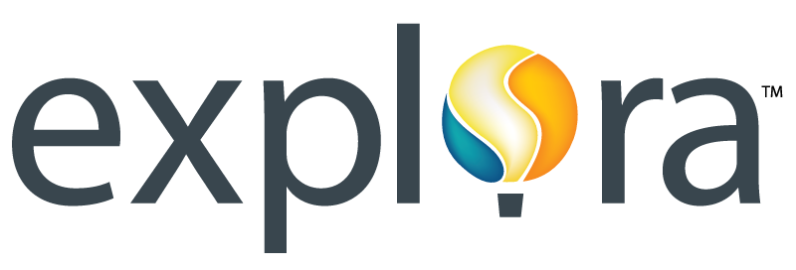

Dear [Teacher/Parent],

I’d like to take a moment to tell you about the online resources offered by EBSCO, now available in our school library through an engaging interface called Explora. Designed with students and educators in mind, Explora provides a safe, trustworthy environment for students to look up articles and facts for research papers, class projects or homework. A far better alternative to websites and search engines, Explora provides students with easy-to-use features and age-appropriate content from the world’s leading magazines and reference books. Available on school computers and from mobile devices, Explora offers the following:

- High-quality, school-appropriate content licensed from reputable publishers recognized by library professionals
- Simple search that quickly delivers relevant results, including magazine and journal articles, primary source documents, newspaper articles and Associated Press videos
- Easy-to-browse categories organized by popular topic
- Topic Overviews that provide students with a starting point for research
- Text-to-speech for HTML articles to assist struggling readers, auditory learners and those developing English-language proficiency
- Full-text translation in more than 30 languages for HTML articles
- Reading level indicators (Lexile Measures) to simplify discovery of texts that match students’ reading abilities
- COPPA compliance, meaning EBSCO does not ask users for personal information
- Google integration, allowing educators to quickly share content to Google Classroom and students to save articles to Google Drive
- Citation tool to help students format references/works cited; option to export citations to NoodleTools, EasyBib and other bibliographic management platforms

I encourage you to explore these resources with your students or even on your own. For access, go to [insert direct URL]. If you are prompted for a User ID and Password, please use the following:

User ID: _______
Password: _______

Optional paragraph for teacher version: In addition, EBSCO Connect offers some great resources for teachers, including thematic units and lesson plans that integrate EBSCO’s online resources into the curriculum. To learn how to use the Curriculum Standards Module, accessible from the top toolbar in Explora, click here.

Please feel free to contact me directly with any questions regarding Explora, or if you have suggestions for how we can help support you and your students via the library’s online resources.

Sincerely,

[Your name & contact information]

